***Christopher Sigouin***

Holland College CIS Student

7 Selkirk Ave

Cornwall, PE C0A 1H5

September 25, 2014

Mr. Dave Arsenault

Clothing Production Manager

Cows Inc.

397 Capital Drive

Charlottetown, PE C1E 2E2

Dear Mr. Arsenault:

Currently I am looking to acquire a letter of recommendation to add to my portfolio. My four months of employment as a T-Shirt Production Tech was an amazing and rewarding experience. I hope that I was able to maintain the quality that shows on each and every garment printed at Cows.

While my classes at Holland College continue, I am nearing a point in my life where decisions will mold my future. I take pride in being prepared and organized for what lies ahead. When the time comes that I am in a position to further my career, I certainly wish to have every resource available to aid me.

I certainly hope that we can discuss the letter further. I will follow up with you at a later time via telephone. My email address is csigouin@hollandcollege.com and contact number 902-666-6666 if you wish to contact me. Thank you for your time and consideration.

Sincerely

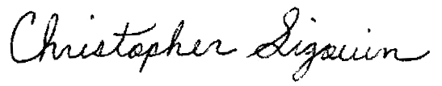

Christopher Sigouin

Holland College CIS Student